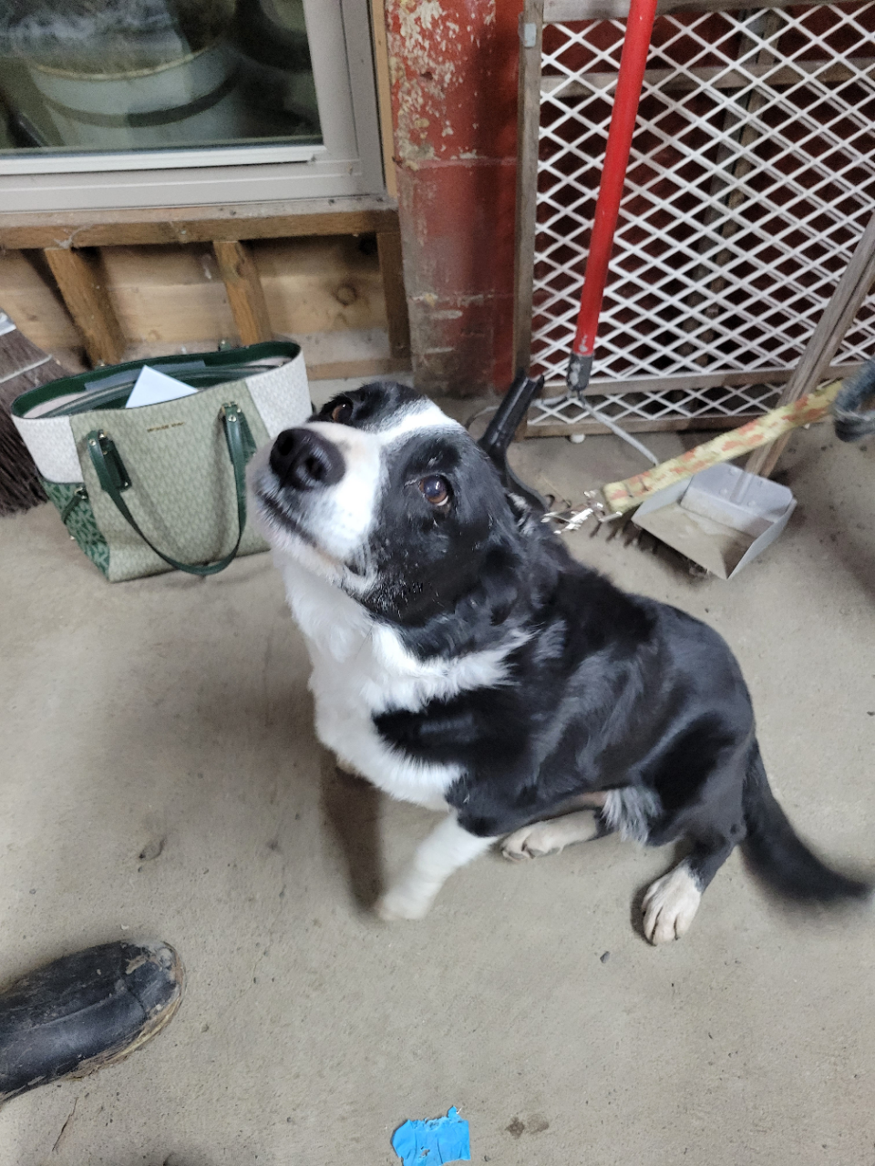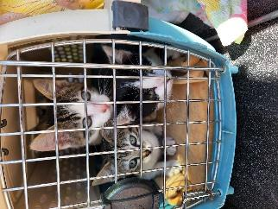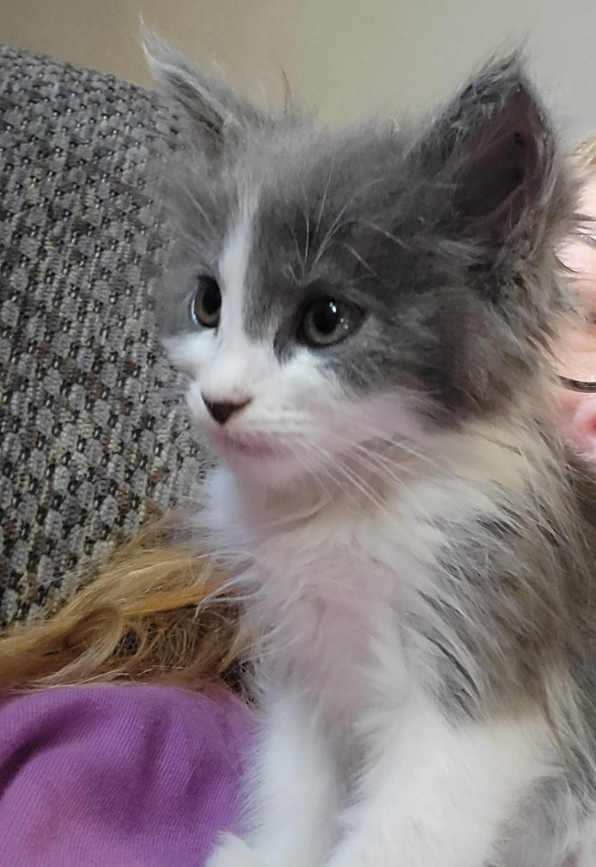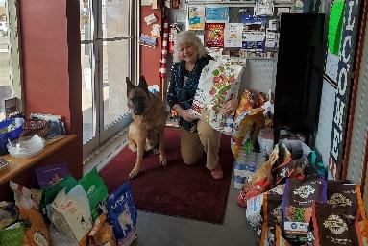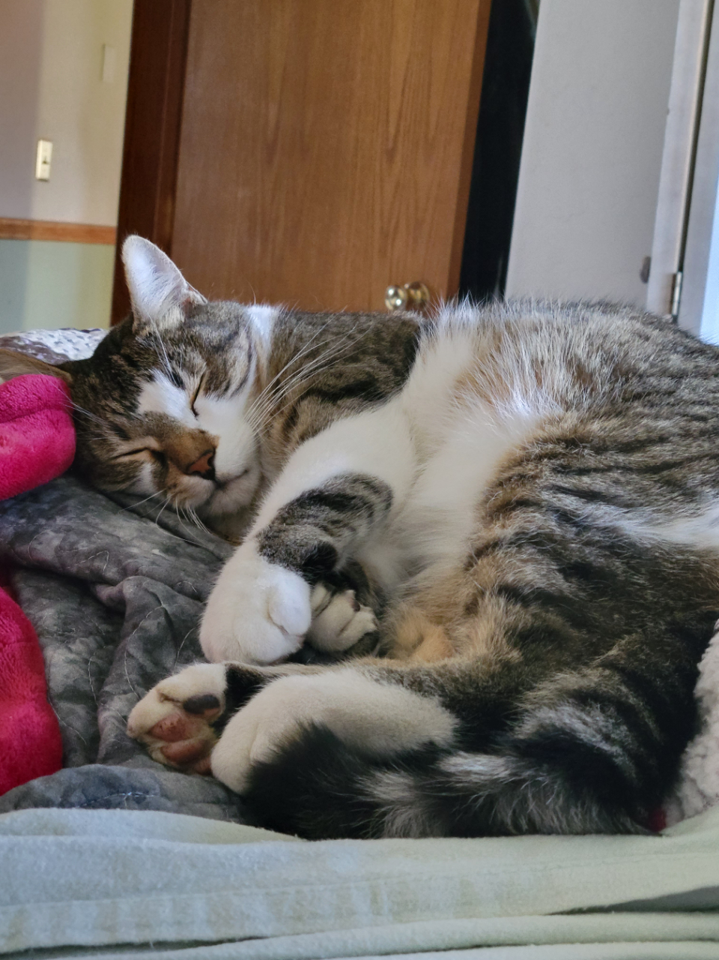

**Fosters**

**Total: 1056**

2020: 60

2021: 183

2022: 214

2023: 350

2024: 249

**Pet Medical Support**

**Total: 183**

2022: 65

2023: 77

2024: 41

**Adoptions**

**Total: 406**

2020: 27

2021: 68

2022: 74

2023: 105

2024: 132

**TNVR**

**Total: 798**

2020: 188

2021: 180

2022: 176

2023: 72

2024: 182

**Number of Times Animal Lives were Improved**

**Since Feb 2020: 4685**

**Transfers**

**Total: 1336**

2020: 271

2021: 357

2022: 355

2023: 257

2024: 96

**Spay/Neuter**

**Vouchers Processed**

**Total: 906**

2020: 38

2021: 116

2022: 209

2023: 331

2024: 212

**Food Donated**

**Total: 7419 dry & 580 cases**

2020: 1975 lbs dry & 252 cases

2021: 2104 lbs dry & 242 cases

2022: 2238 lbs dry & 59 cases

2023: 822 lbs dry & 27 cases

2024: 315 lbs

**www.ARFGrangeville.org**

**501(c)3 non-profit**

**EIN #: 47-0991943**